Practical 1

Vue Directives

Aim:
To create a Vue app and demonstrate the understanding of Vue directives like v-if/else, v-show, v-for, v-on and v-model

Theory:

Vue Directives
Vue directives are special attributes that start with the prefix v-. They provide reactive behavior to HTML elements, allowing the DOM to update automatically whenever the underlying data changes.
1. v-if
The v-if directive conditionally renders an element. The element is created and displayed only when the specified condition evaluates to true.

Syntax
<p v-if="loggedIn">Welcome User</p>

2. v-else
The v-else directive is used together with v-if to display an alternate block when the v-if condition is false.

Syntax
<p v-if="loggedIn">Welcome</p>
<p v-else>Please Login</p>

3. v-show
The v-show directive controls the visibility of an element using CSS (display: none). The element always exists in the DOM but is hidden or shown based on the condition.

Syntax
<p v-show="showError">
Invalid Login
</p>

4. v-for
The v-for directive is used to render a list of items by iterating over an array or object.

Syntax
<li v-for="item in menu">
{{ item }}
</li>

5. v-on
The v-on directive attaches event listeners such as click, submit, mouseover, etc. The shorthand for v-on is @.

Syntax
<button v-on:click="login">
Login
</button>

6. v-model
The v-model directive creates two-way data binding between form inputs and Vue data. Whenever the user changes the input, the corresponding variable is automatically updated.

Syntax
<input v-model="username">

Code Snippets:

1. Import Statements
import { ref } from "vue";
import users from "./users.json";

2. users.json
[
{
"username": "admin",
"password": "admin123",
"role": "Admin"
},
{
"username": "user",
"password": "user123",
"role": "User"
}
]

3. Login Form (v-model, v-on, v-if)
<div class="login-box" v-if="!loggedIn">
<input v-model="username" />
<input type="password" v-model="password" />
<button @click="login">Login</button>

<p v-show="showError">
Invalid Username or Password
</p>
</div>

4. Dashboard (v-else, v-show)
<div class="dashboard" v-else>

<div
class="admin-view"
v-show="currentUser.role==='Admin'">

Admin Dashboard

</div>

<div
class="user-view"
v-show="currentUser.role==='User'">

User Dashboard

</div>

</div>

5. v-for
<li
v-for="(task,index) in userTasks"
:key="index">

{{ task.title }}

</li>

6. Login Function
function login() {
const user = users.find(
u =>
u.username === username.value &&
u.password === password.value
);

if (user) {
currentUser.value = user;
loggedIn.value = true;
} else {
showError.value = true;
}
}

Output:
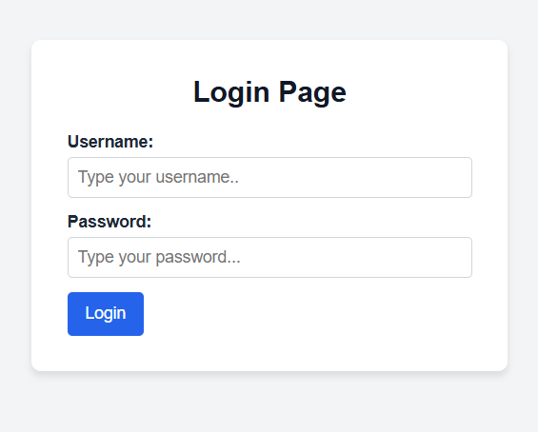

1) Login Page
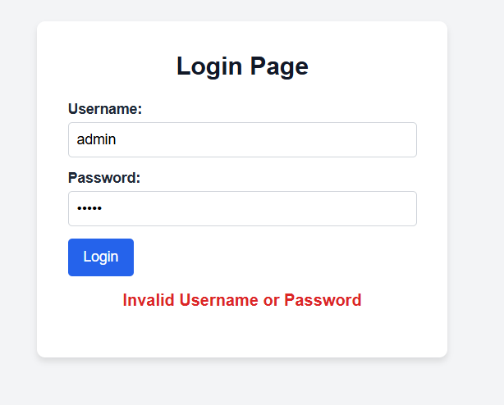

2) Login page on wrong credentials

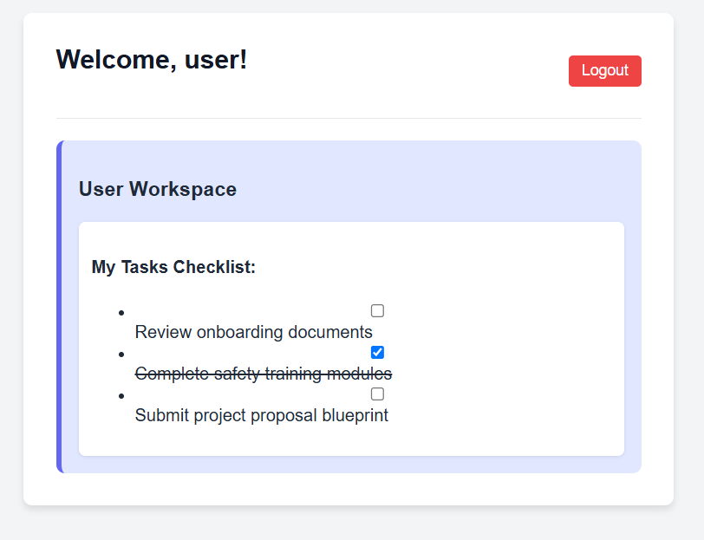

3) User Page

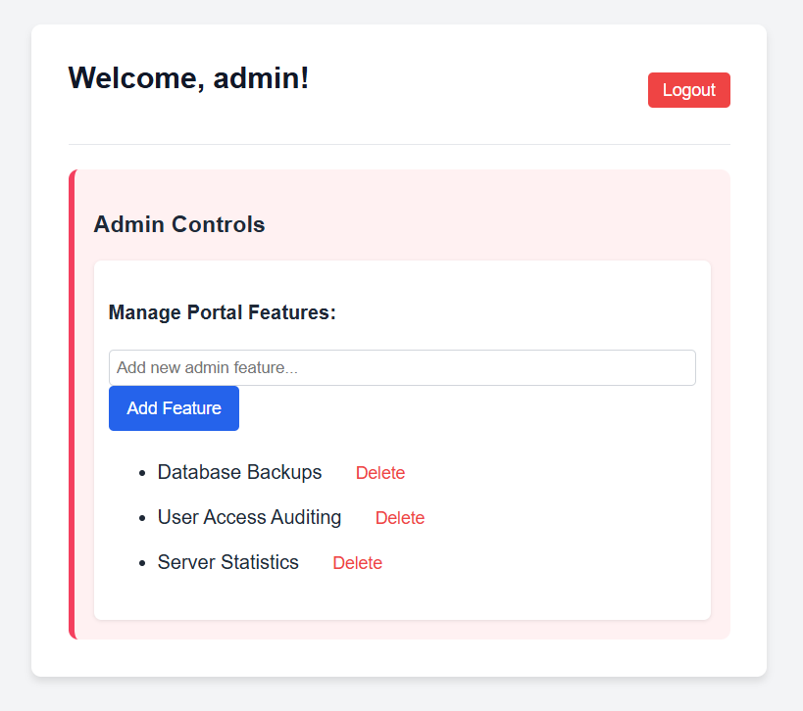

4) Admin Page

